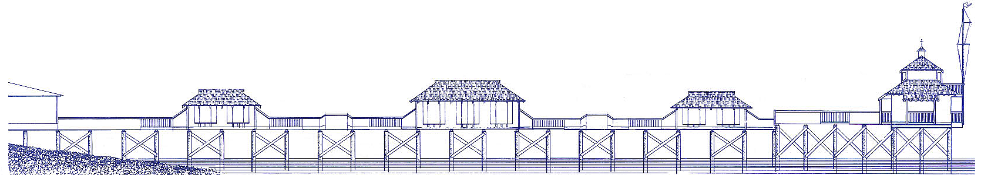

COWICHAN BAY MARITIME CENTRE
COWICHAN WOODEN BOAT SOCIETY

Box 22, 1761 Cowichan Bay Road, Cowichan Bay, BC V0R 1N0
250.746.4955 ~ www.classicboats.org ~ cwbs@classicboats.org
______________________________________________________________________________

MEMBERSHIP FORM 2023

Help support our Centre! In order to operate we rely on funding from government grants, corporate sponsorship, community supporters and members like you. Your membership is important and ensures we can focus on the important stuff…
- Preservation of maritime artifacts
- Building and pier maintenance
- Community events
- Wooden boat building courses
- Educational seminars
- Revitalization of displays
Membership has many perks including having a lot of fun. Here’s more…
- Complimentary use of our fleet of classic row boats
- Complimentary entrance to the museum
- Access to our extensive nautical library
- Issues of “Soundings”, society newsletters.
- Access to our workshop space and tools. Check at front desk for fees and availability.
- Priority invitations to museum events and guest speakers.
- Courses for all ages. Boatbuilding, Women’s Woodworking, Junior Captains’ Camp, and more.
- Ways availability for boats
- Volunteer opportunities: events and renovating boats

Membership Rates
- Individual $45
- Family $60
- Student $10

Please complete form below - - - - - - - - - - - - - - - - - - - - - - - - - - - - - - - - - - - - - - - - - - - - - - - - - - - - - - - - - - - - - - - - - -

Are you renewing your membership? ____ Yes ____ No

Yes, I want to become a member. ____ Individual ($45) ____ Family ($60) ____ Student ($10) Date __________
Name: _________________________________ Phone: _______________________________
Address: ______________________________________________________________________
City: ___________________________________ Prov./ State: ___________________________
Postal/ Zip Code: _________________________ Email: _______________________________
Today’s Date: __________________________ Payment made by: ___ Cash ___ Cheque ___ CC
*Please make cheques payable to Cowichan Wooden Boat Society.

VOLUNTEER OPPORTUNITIES

Volunteers are an integral part of the Cowichan Bay Maritime Centre’s operations. They are essential to support the day to day activities as well as special events put on throughout the year. We invite you to share your time and talents. Please indicate below your areas of interest.

___ Reception / Greeting visitors
___Building Maintenance
___Assistance with special events (festivals, children’s programs, raffle sales, etc.)
___Cleaning
___Workshop (general assistance or perhaps teaching a course)
___Librarian
___Indigenous/local knowledge
___Other, please list your skills and interests ________________________________________________________________________________________________________________________________________________________________________________________________________________________________________________________________________________________________________________________________________

